Capstone Project 2

Architecture Design
Version 1.1
Date: 10/05/2023

TICKET BOOKING AND SCHEDULE TRACKING SYSTEM

Submitted by

Architecture Review Panel Representative:
Name Signature Date

Capstone Project 2 - Mentor:
Name Signature Date

PROJECT INFORMATION
Project Acronym | TSBooking
Project Title | Ticket Booking and Schedule Tracking System
Start Date | March 10, 2023 | End Date | May 25, 2023
Lead Institution | International School, Duy Tan University
Project Mentor | PhD, Thuan, Nguyen Tan  Email: thuannt.it.dtu@gmail.com  Tel: 0905626276
Scrum Master / Project Leader & contact details
Partner Organization
Project Web URL
Team Members | Name | Email | Tel

REVISION HISTORY
Version | Date | Comments | Author | Approval
1.0 | 01/04/2023 | Initial Release | C2SE.34
1.1 | 10/05/2023 | Modify | C2SE.34

DOCUMENT APPROVALS
The following signatures are required for approval of this document.

Contents
1. INTRODUCTION 1
1.1. Project overview 1
1.2. Purpose 1
1.3. Business driver 1
1.3.1. Business Problems 1
1.3.2. Business Need 1
2. ARCHITECTURE DRIVER 2
2.1. Business constraints 2
2.2. Technical constraints 2
2.3. Functional requirement 2
2.4. Quality attributes 2
2.4.1. Security 2
2.4.2. Availability 3
3. ARCHITECTURE OVERVIEW 4
3.1. System context 4
3.2. Component and connector 5
3.3. Module view 7
3.4. Allocation view 8
4. REFERENCES 10

FIGURES
Figure 1. System context 4
Figure 2. C&C view 6
Figure 3. Module view 7
Figure 4. Allocation view 8

INTRODUCTION

Project overview
TSBooking is a web page to help users set coach tickets on the online platform quickly and conveniently. The system can display the information of the trip, customers can exchange with the operators and choose the appropriate trip. The system also has a chatbot so that users can search for necessary information about trips. In addition, our system can help customers cancel or change their ride schedule.

Purpose
This document provides an overview of how the project will be developed. It includes an overview of the product, an overview of the process, and an overview of the project team.
In addition, this project is under monitoring by the college campus environment, so, this is a non-profit project and done with cost and time is limited. So, the goal for this project is to be released with 70% of the whole function.
Through-out the project, the conflicts between team members, the problem occurring during the developing phase, will be a big contribution for All members in learning and developing the technician-skills such as code, test, design and soft-skills such as teamwork, presentation, solving problems.

Business driver
    - Business Problems
- Customers are not proactive about booking time.
- Crowded customers at ticket counters.
- It's easy to forget the time of booking a bus ticket.
- Booking tickets are easily lost or damaged.
- The consultation and provision of trip information over the phone is still inadequate.
    - Business Need
- Easily manage the number of customers booking tickets.
- Book tickets quickly against.
- Reduced waiting time for users.
- Avoid large gatherings at ticket counters.
- Pay and receive tickets quickly.
- ARCHITECTURE DRIVER
  - Business constraints
- Sources: 5 people.
- Project was started on: 01/03/2023.
- Project will be ended on: 25/05/2022.
- Project will be finished in 86 days.
- Cost: $5768
  - Technical constraints
Technical to develop:
- Programming Language: JavaScript, CSS, HTML, PHP.
- Frameworks / Libraries: Bootstrap, Laravel.
- Database Management System: MySQL
Environment:
- Web browsers: Google Chrome, CocCoc, Microsoft Edge.
  - Functional requirement
References to Product Backlog specification
  - Quality attributes
    - Security
Scenario: When a user registers an account, their password is encrypted through 3 layers of security before being saved in the database.
Type | Security
Stimulus | Register account
Source of stimulus | User
Environment | In runtime
Artifact stimulated | The system
Response | Encrypt password
Response measure | Encrypted through 3 layers of security

Scenario: When the user wants to pay, the system will provide a confirmation code to their phone number. The code will be refreshed if the user does not enter it or enters it incorrectly within 1 minute.
Type | Security
Stimulus | Provide Verification Code
Source of stimulus | User Stimulation
Environment | In runtime
Artifact stimulated | The system
Response | Confirmation code sent to phone
Response measure | Measure The code will be refreshed if the user does not enter it or enters it incorrectly within 1 minute
    - Availability
Scenario: The user sends a request to the server when the main web server has a problem or there are too many requests that make the server take a long time to respond, the system will transfer the user's request to the backup web server.
Type | Security
Stimulus | Sends request to sever
Source of stimulus | User
Environment | Server is overloaded or down
Artifact stimulated | The system
Response | transfer the user's request to the backup web server
Response measure | No downtime

- ARCHITECTURE OVERVIEW
This section shows the diagrams which bounds our target system and describes the architecture and interaction between components.
  - System context
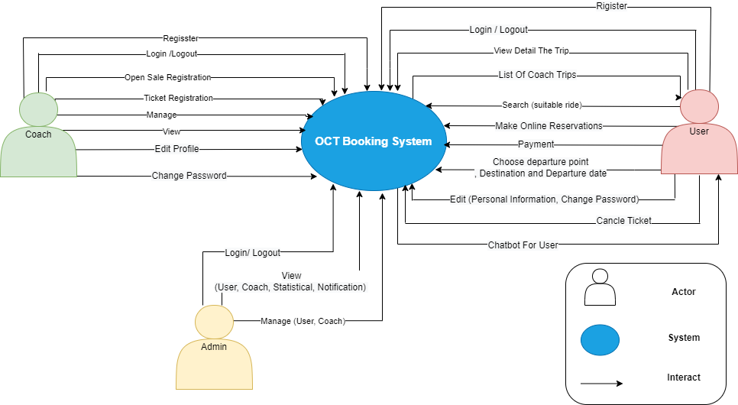
TSBooking
Figure 1. System context
The Admin, they can:
- Login/Logout
- View (User, Coach, statistical)
- Manage (User, Coach)
- Notification

The Coach, they can:
- Register
- Login/Logout
- Open Sale Registration
- Ticket Registration
- View
- Manage Trip
- Edit Profile
- Change Password
The Users, they can:
- Rigister
- Login / Logout
- View Detail The Trip
- Search (Suitable ride)
- Make Online Reservations
- Payment
- Edit (Personal Information, Change Password)
- Cancle Ticket
- Chat With The System
  - Component and connector
We mainly used a C&C view to argue and reason about architectural properties, quality attribute requirements, and functional requirements that the system must add here. This view type partitions the system into components that have some runtime presence such as processes, objects, data stores, and connectors or that represent pathways of communication such as data flows and access to shared storage.
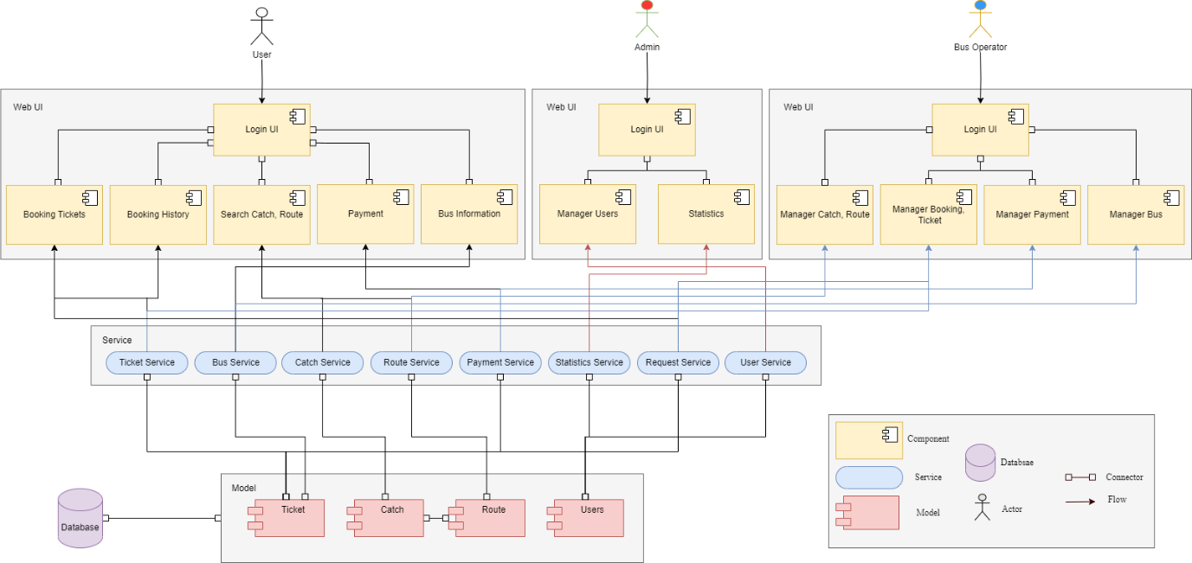
Figure 2. C&C view
Prose
The web client sends and receives data from the server through the web service API. User operations will send requests to the server through the API, the server will process the data with the corresponding models and access the database to retrieve data, then respond to the information to the web client through the API to display it to the user.
Element | Responsibilities
Website application | The website application consists of two parts for the management and the garage staff to use. Garage staff use the web to view a list of users who register for bus tickets, manage departure time, manage arrival time and manage vehicles. Administrators use the web to manage user accounts, assign permissions, and back up data.
Database | The database is the component that contains information about the user, ticket information has been booked, payment history. All the data the system needs

  - Module view
This view type partitions the system into a unique non-overlapping set of decomposable implementation modules. The goal is to show how the source code is decomposed, as well as the dependencies between modules. In other words, it shows the decomposition.
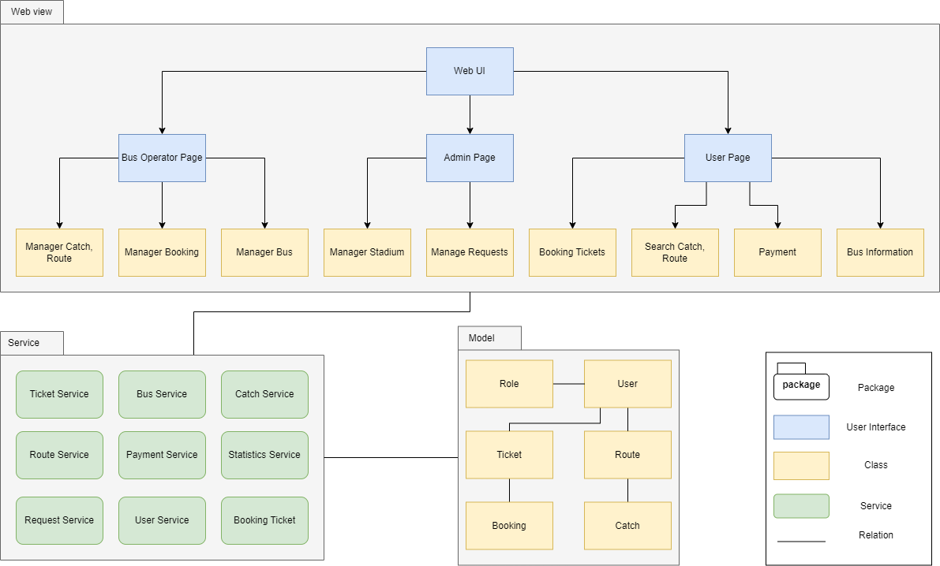
Figure 3. Module view
Prose
Element | Responsibilities
Web View | The website package contains management modules for admin and coach
Dialog flow Service | A natural language comprehension platform used to design and integrate chat user interface into bots
Models | Object data modules connect to tables in the database for transmission to the system interface
Description: The system includes application views, web views, Dialog flow, models, and services. After the user interacts with the UI. The data will be requested to the respective service, which will then pass it directly to the respective models or Dialog flow. The returned data will be displayed on the user interface.
  - Allocation view
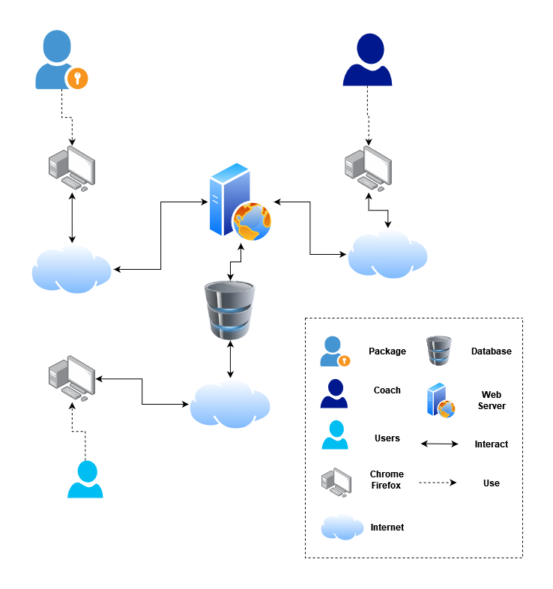
Figure 4. Allocation view
The allocation view models the run-time architecture of a system. It shows the configuration of the hardware elements when the system is deployed.

Prose
The system is deployed on web environment (using Laravel library). They interact with the server to read and write data from the MySQL database. In addition, the system interacts with Dialog flow to design conversations for the Chatbot.
Element | Responsibilities
Admin, Coach, Customer | The person who wants to use our system
Website | Device running browser and helping Admin, Coach, Customer to use the functions of the website.
Dialog flow | A natural language comprehension platform used to design and integrate chat user interface into bots
Web service | Web service is where the user logs in to the system to view information
Database server | A place where all data about vaccines, user information, ... Is organized in tabular form

- REFERENCES
No. | References | Document Information
1 | Design standards,  Document standards | https://www.softwarearchitecturebook.com/svn/main/slides/ppt/26_Standards.ppt
1 | Design standards,  Document standards | https://standards.ieee.org/standard/1471-2000.html
1 | Design standards,  Document standards | https://ieeexplore.ieee.org/document/917550
2 | Patterns | https://en.wikipedia.org/wiki/Architectural_pattern
3. | Evaluation standards | https://www.iso.org/obp/ui/#iso:std:iso-iec-ieee:42030:ed-1:v1:en
3. | Evaluation standards | https://gabrielfs7.github.io/software-architecture/2019/10/18/atam-analyze-evaluate-architecture/

